Phase-2 :Decoding Emotion to Sentiment Analysis of Social Media Conversation

Student Name: M.Madhan kumar
Register Number: 510123106027
Institution: Adhiparasakthi College of Engineering
Department: B.E.Electronics and Communication Engineering
Date of Submission: 10/05/2025
Github Repository Link:

1. Problem Statement
- Problem statement for Decoding emotion through sentiment analysis of social conversation
- Problem statement for Decoding emotion through sentiment analysis of social conversation
- Sentiment analysis faces significant challenges in accurately decoding complex human emotions from social media conversations due to linguistic nuances, cultural variations, and evolving language patterns. Traditional approaches often oversimplify emotions into binary (positive/negative) or broad categories, failing to capture the full spectrum of 28+ distinct emotional states observed in modern digital communication. This limitation hinders applications ranging from mental health support to customer experience optimization.
- Key challenges requiring attention:

- Contextual complexity: Human emotions often involve sarcasm ("Great, another system outage!"), irony, and context-dependent expressions that defy literal interpretation.
- Cultural specificity: Emotional expressions vary significantly across demographics, with emojis and slang carrying different meanings in regional contexts.
- Multidimensional emotions: Conversations frequently contain mixed sentiments ("Love the camera quality but hate the battery life") requiring simultaneous recognition of conflicting emotional states.
- Dynamic language evolution: Rapid emergence of internet slang, abbreviations, and platform-specific lingo (e.g., "sus," "ratio") challenges static emotion models.
- Advanced deep learning architectures like BERT and RoBERTa show promise in addressing these limitations through contextual embedding analysis. However, current implementations still struggle with real-world deployment challenges including processing short, informal texts (tweets, comments) and maintaining accuracy across multilingual posts. The proposed research aims to bridge this gap by developing an adaptive emotion recognition framework that combines transformer-based NLP with cultural contextualization layers, potentially enhancing applications in mental health monitoring, brand perception analysis, and educational feedback interpretation

2. Project Objectives
Decoding emotions through sentiment analysis of social media project objectives
Decoding emotions through sentiment analysis of social media project objectives
Project Objectives for Decoding Emotions through Sentiment Analysis of Social Media
Understanding the objectives of a project focused on decoding emotions via sentiment analysis of social media involves several key aims and motivations:

1. Accurate Emotional Classification:Develop and implement an advanced sentiment analysis system capable of accurately assessing and categorizing the emotional tone expressed in social media content. Move beyond simple polarity (positive/negative/neutral) to classify nuanced emotions such as happiness, sadness, fear, anger, surprise, and disgust.

2. Leveraging Advanced Techniques:
Utilize Natural Language Processing (NLP) and machine learning algorithms to extract and classify emotions from unstructured text data.
Incorporate features such as emoticons, degree words, negations, parts of speech, and other grammatical cues for richer emotion detection.

3. Automation and Scalability:Automate the creation of training datasets to minimize manual annotation, enabling the analysis of large-scale social media data efficiently.
Build scalable systems that can handle the massive and continuous influx of social media posts.

4. Real-Time and Granular Insights:
Provide real-time analysis and visualization of emotional trends across different topics, time periods, and geographic locations.Enable granular analysis at the level of individual users, regions, or topics, supporting applications like mood tracking and location-based sentiment mapping.

5. Practical Applications:Empower businesses, organizations, and individuals to:
Understand customer perception and public opinion.
Enhance reputation management by monitoring and responding to sentiment shifts.
Improve customer service by identifying grievances or satisfaction levels.
Conduct market research and competitor analysis based on emotional trends.
Support decision-making through actionable insights derived from emotional data.

6. User-Friendly Access: Design intuitive interfaces and dashboards for non-technical users to access and interpret sentiment analysis results, making the technology accessible beyond data scientists.

7. Addressing Challenges:Account for linguistic nuances such as sarcasm, slang, and cultural context to improve the accuracy and reliability of emotion detection.
Continuously refine models to adapt to evolving language and social media trends.

In summary:
The main objectives of a sentiment analysis project focused on decoding emotions in social media are to accurately classify complex emotions, leverage advanced NLP and machine learning, automate large-scale analysis, provide actionable and real-time insights, and make these insights accessible and useful for a wide range of stakeholders.

Flowchart of the Project Workflow
Flow Chart of Project Workflow: Decoding Emotions through Sentiment Analysis of Conversation
Below is a structured flow chart outline for a project aimed at decoding emotions from conversations using sentiment analysis. Each step is described to reflect standard practices in conversational sentiment analysis and emotion recognition.

1. Data Collection

Gather conversational data (text, audio, or video transcripts) from relevant sources (e.g., chat logs, interviews, therapy sessions).

2. Data Preprocessing

Clean and normalize the text (remove noise, correct typos, handle slang/abbreviations).

Segment conversations into utterances or turns.

(If multimodal) Extract audio or visual features as needed.

3. Context Modeling

Model conversation context by incorporating historical utterances to capture the flow and dependencies between turns.

Use context-aware structures (e.g., recurrent neural networks, context windows).

4. Feature Extraction

Extract linguistic, semantic, and emotional features from each utterance.

For advanced models, use neural feature extractors (e.g., contextual embeddings, emotional recurrent units).

5. Sentiment and Emotion Classification

Apply a sentiment analysis model to classify each utterance or segment into sentiment categories (positive, negative, neutral) and/or emotion labels (e.g., happy, sad, angry, surprised).

Use classifiers such as neural networks, SVMs, or transformer-based models.

6. Emotion Decoding and Aggregation

Aggregate emotion predictions across the conversation to form an emotional profile.

Optionally, map results onto emotion models (e.g., circumplex model: valence-arousal).

7. Visualization and Interpretation

Visualize the distribution and progression of emotions (e.g., donut charts, line graphs over time).

Provide actionable insights or feedback based on detected emotional trends.

- Evaluation and Validation
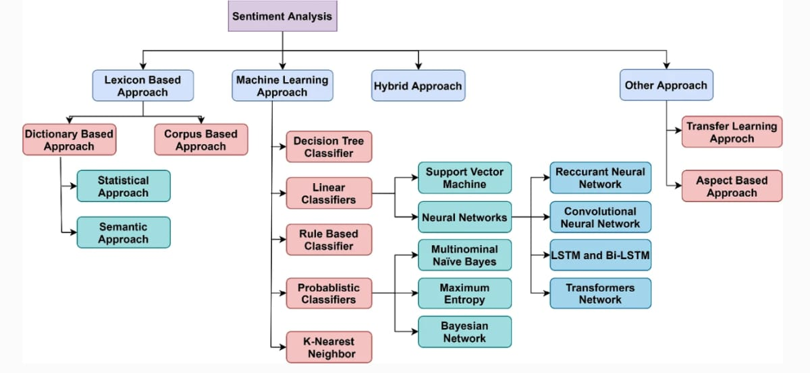

Assess model performance using annotated datasets and appropriate metrics (accuracy, F1-score).

Conduct qualitative validation (e.g., expert review, user studies).

Example Flow Chart Representation
text
flowchart TD
A[Data Collection] --> B[Data Preprocessing]
B --> C[Context Modeling]
C --> D[Feature Extraction]
D --> E[Sentiment & Emotion Classification]
E --> F[Emotion Decoding & Aggregation]
F --> G[Visualization & Interpretation]
G --> H[Evaluation & Validation]
This workflow ensures that emotion decoding from conversation is context-sensitive, accurate, and interpretable, following best practices in conversational sentiment analysis research

Data Description
Data Description for Decoding Emotions through Sentiment Analysis of Social Media
The datasets used for sentiment analysis of social media are typically large collections of user-generated content sourced from platforms such as Twitter, Reddit, Facebook, and Instagram. These datasets are designed to capture the wide range of emotions, trends, and interactions present in online conversations.

Key Components of Social Media Sentiment Datasets
Text Content: The primary feature is the raw text of social media posts, such as tweets, comments, or reviews. This text is the main input for emotion and sentiment analysis.

Sentiment Labels: Many datasets include pre-assigned sentiment labels for each post, indicating whether the sentiment is positive, negative, neutral, or, in some cases, more granular emotions (e.g., anger, joy, sadness). For example, the Sentiment140 dataset uses labels like '0' for negative and '4' for positive sentiment.

Metadata:Additional contextual information is often included, such as:
Timestamps: When the post was created.
User Information: Anonymized user IDs or handles.
Location: Country or region from which the post originated.
Hashtags: Topics or themes associated with the post.
Engagement Metrics: Number of likes, retweets, or replies.
Data Format:The data is usually stored in structured formats like CSV, with columns for each attribute (e.g., sentiment, text, date, user, etc.).

Example Datasets
Social Media Sentiments Analysis Dataset:Contains user-generated content from various platforms, including text, timestamps, hashtags, countries, likes, and retweets.

Sentiment140 Dataset:Comprises 1.6 million tweets, each labeled as positive or negative, and includes columns for sentiment, tweet ID, date, query, user, and the original tweet text. This dataset is widely used for training and benchmarking sentiment analysis models.

Reddit and Twitter Comments Dataset:Features social media comments and customer reviews, collected from platforms like Reddit and Twitter, with sentiment labels for each entry.

Data Preprocessing and Challenges
Preprocessing Steps:

1.Text cleaning (removal of mentions, emojis, special characters, and unnecessary spaces)

2.Lowercasing and normalization

3.Stop word removal and lemmatization

4.Handling abbreviations and correcting spelling errors

Challenges:

- Informal language, slang, and abbreviations

- Presence of emojis and non-standard grammar

- Imbalanced sentiment classes (e.g., more negative than positive posts)

- Contextual and cultural nuances affecting sentiment interpretation

Data Preprocessing
Data Processing for Decoding Emotions through Sentiment Analysis of Social Media
Data processing is a critical phase in sentiment analysis projects, especially when working with social media data, due to its unstructured and noisy nature. Below is a structured overview of the main steps and techniques involved:

1. Data Collection
Gather social media data using APIs (e.g., Twitter API, Facebook Graph API) or web scraping tools to obtain posts, comments, and associated metadata.

2. Data Cleansing and Preprocessing
Noise Removal: Eliminate irrelevant information such as HTML tags, special characters, URLs, email addresses, and emojis, which do not contribute to sentiment analysis.

Stopword Removal: Remove common words (e.g., "the," "is," "and") that do not carry significant semantic meaning, reducing dimensionality and improving computational efficiency.

Normalization: Convert text to lowercase, handle misspellings, and standardize abbreviations to ensure consistency.

Tokenization: Split text into individual words or tokens for further processing.

Stemming and Lemmatization: Reduce words to their root forms to unify similar terms (e.g., "running" to "run").

Handling Hashtags and Mentions: Remove or encode hashtags and user mentions, as they can introduce noise or be used as features depending on the analysis goals.

Filtering Non-English or Irrelevant Content: Exclude posts in languages not relevant to the analysis or those outside the scope of the project.

3. Feature Extraction
Bag of Words / N-grams: Represent text as a collection of words or sequences of words to capture context.

TF-IDF (Term Frequency-Inverse Document Frequency): Quantify the importance of words in the context of the entire dataset.

Word Embeddings: Use models like Word2Vec or GloVe to capture semantic relationships between words for deeper analysis.

Part-of-Speech Tagging: Identify grammatical roles of words to enhance feature richness.

4. Sentiment and Emotion Classification
Model Selection: Use machine learning algorithms (e.g., logistic regression, decision trees, random forests) or deep learning models (e.g., RNNs, transformers) to classify sentiment and emotions based on extracted features.

Training and Validation: Train models on labeled data and validate their performance to ensure accuracy and generalizability.

5. Post-Processing and Visualization
Result Aggregation: Summarize sentiment/emotion scores at various levels (e.g., per user, region, or topic).

Visualization: Present findings through dashboards or visual tools for actionable insights.

Exploratory Data Analysis (EDA)
Decoding Emotion Through Sentiment Analysis of Social Media Conversation
Social media sentiment analysis is the process of examining user-generated content on platforms like Twitter, Facebook, and Instagram to uncover the emotions and opinions expressed about brands, products, or topics. This approach goes beyond simply counting mentions or comments; it aims to decode the underlying emotional tone-positive, negative, neutral, or even more nuanced emotions-within vast volumes of online conversations.

Key Components of Social Media Sentiment Analysis
Polarity: Identifies whether the sentiment is positive, negative, or neutral.

Intensity: Measures how strongly an emotion is expressed.

Emotion Detection: Advanced models can extract specific emotions such as joy, anger, sadness, trust, or fear, moving beyond basic polarity.

Subjectivity: Distinguishes between subjective opinions and objective statements.

Exploratory Data Analysis (EDA) in Sentiment Analysis
EDA is a crucial first step in sentiment analysis, helping to understand the structure, patterns, and nuances in social media text data. Typical EDA steps for social media sentiment analysis include:

Text Statistics: Analyzing word counts, sentence lengths, and frequency of key terms or hashtags.

Visualization: Using word clouds, bar charts, or time series plots to visualize the distribution of sentiments and emotions.

Sentiment Distribution: Calculating the proportion of positive, negative, and neutral posts, and tracking changes over time.

Emotion Mapping: Identifying the prevalence of specific emotions (e.g., joy, anger, care, sadness) within the dataset.

Topic Modeling: Exploring which topics are associated with particular sentiments or emotions.

Tools and Techniques
Lexicon-Based Methods: Tools like VADER (Valence Aware Dictionary and Sentiment Reasoner) are popular for social media sentiment analysis, providing probabilities for positive, negative, and neutral sentiments.

Machine Learning & NLP: Advanced models such as RoBERTa can extract a wide range of emotions (up to 28 or more), offering deeper insights into the emotional landscape.

Real-Time Monitoring: Modern sentiment analysis tools offer real-time tracking and alerts, enabling brands to respond promptly to shifts in public opinion.

Insights and Applications
Understanding Public Perception: Sentiment analysis reveals how people truly feel about a brand, product, or event, beyond surface-level metrics like likes or shares.

Crisis Prevention: Early detection of spikes in negative sentiment can help prevent PR disasters.

Trend Spotting: Identifying emerging topics and associated emotions allows brands to capitalize on trends or address concerns proactively.

Personalized Engagement: Tailoring responses based on detected sentiment or emotion can improve customer relationships and brand loyalty.

Challenges
Complexity of Emotions: Emotions in social media text are complex and may not fit neatly into categories; sarcasm, irony, and cultural context can be difficult for algorithms to interpret accurately.

Volume and Variety: The massive and diverse nature of social media data requires scalable and robust analytical tools.

Summary Table: Sentiment vs. Emotion Analysis
Aspect Sentiment Analysis Emotion Detection (Advanced)
Output Positive, Negative, Neutral Specific emotions (joy, anger, etc.)
Methods Lexicon, rule-based, ML Deep learning (e.g., RoBERTa), NLP
Complexity Moderate High
Use Cases Brand monitoring, reputation Mental health, user profiling, deeper insights
Challenges Sarcasm, context Subtlety, overlapping emotions
By applying exploratory data analysis to social media sentiment and emotion data, organizations can unlock actionable insights, understand public mood in real time, and make informed decisions to strengthen their social media strategies and overall brand health.

11.Feature Engineering
Feature engineering for Decoding emotions through sentiment analysis of social conversation
Feature engineering is a critical step in sentiment analysis and emotion detection from social conversations, such as those found on social media platforms. It involves transforming raw textual data into meaningful features that machine learning models can use to accurately interpret and classify emotions.

Key Steps in Feature Engineering for Emotion Decoding
Text Preprocessing

Tokenization: Splitting text into words or phrases.

Removal of stop words, punctuation, and special symbols.

Lemmatization or stemming to reduce words to their root forms.

Feature Extraction Techniques

Statistical Features:

Bag-of-Words (BoW): Counts word occurrences.

TF-IDF (Term Frequency-Inverse Document Frequency): Weighs words by their importance in the document relative to the corpus.

- grams: Captures sequences of words to understand context and phrase-level sentiment.
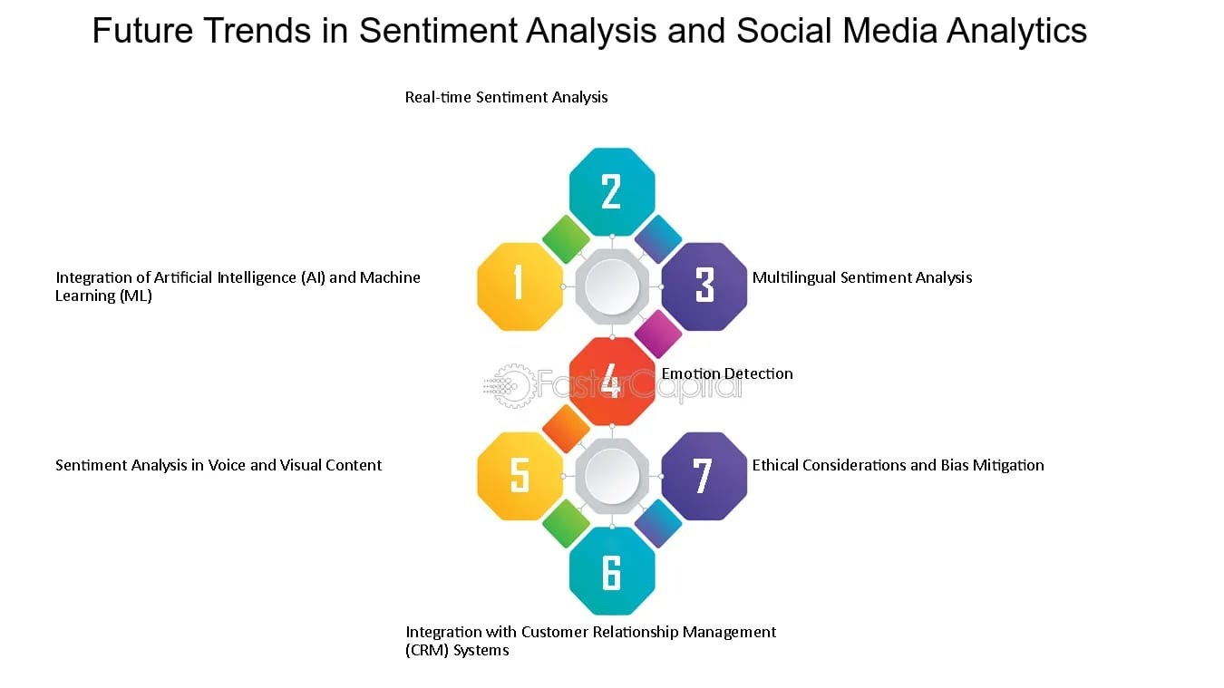

Semantic Features:

Word Embeddings (e.g., Word2Vec, GloVe, FastText): Represent words in dense vector space, capturing semantic relationships.

Sentiment Lexicons: Use dictionaries of words labeled with sentiment or emotion scores.

Emoticons and Punctuation: These can signal emotional intensity or sarcasm.

Custom Features: Sentence length, use of uppercase, exclamation marks, hashtags, and user mentions, which may indicate emotional emphasis in social media contexts.

Feature Engineering Configurations

Combining preprocessing (like stemming) with feature extraction (e.g., TF-IDF) and data augmentation can improve model performance.

Experimenting with different combinations of features and classifiers (e.g., logistic regression, SVM, neural networks) is essential for optimizing accuracy and F1 scores.

Emotion Models and Labeling
Common emotion models used for annotation include Ekman’s six basic emotions (joy, sadness, anger, fear, disgust, surprise) and Plutchik’s wheel of emotions, sometimes extended with additional states for richer analysis.

These models provide the target labels for supervised learning tasks in emotion detection.

Challenges in Feature Engineering for Emotion Detection
Contextual Understanding: Social conversation often includes sarcasm, irony, slang, and ambiguous expressions, making it difficult for models to decode true emotions without advanced contextual features.

Domain Adaptation: Emotional expression varies across platforms and cultures, requiring adaptable and robust feature engineering strategies.

Multi-Label and Mixed Emotions: A single message may convey multiple emotions, necessitating features that can capture such complexity.

Typical Workflow

Data Collection: Gather social conversation data (e.g., tweets, posts).

Preprocessing: Clean and prepare the text.

Feature Extraction: Apply statistical, semantic, and custom feature engineering.

Model Training: Use labeled data to train machine learning or deep learning models.

Evaluation: Assess model performance using metrics like accuracy and F1 score.

Brand Monitoring: Analyze public sentiment and emotional trends about products or services.

Customer Insights: Understand nuanced customer feedback for product improvement.

Trend Analysis: Track shifts in collective emotions during events or crises

8. Model Building

Model building for decoding emotions through sentiment analysis of social conversation

Model Building for Decoding Emotions through Sentiment Analysis of Social Conversation

Sentiment analysis-also known as opinion mining-is the computational process of identifying and categorizing subjective information in text data, especially from social conversations on platforms like social media, forums, and reviews. The goal is to determine the emotional tone behind the text, classifying it as positive, negative, neutral, or even more nuanced emotions such as happiness, anger, or sadness.
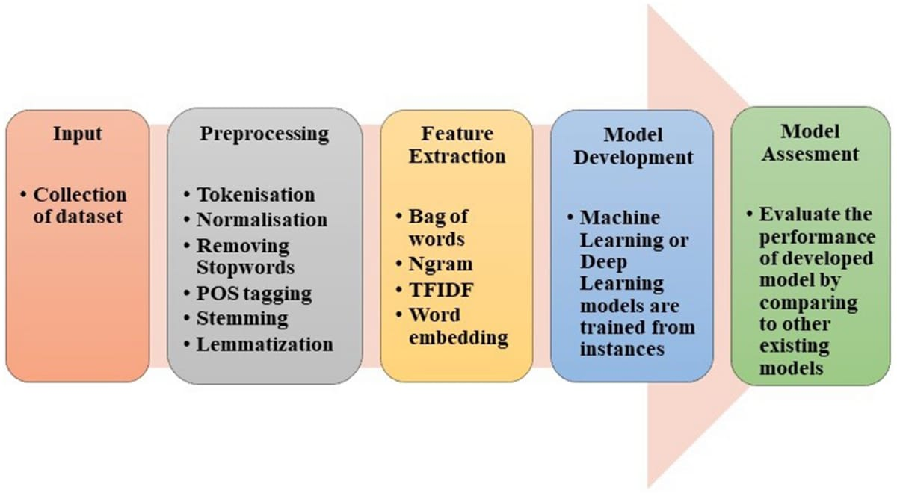

Key Steps in Sentiment Analysis Model Building

1. Data Collection Gather large datasets of social conversation text, such as tweets, Facebook posts, or online reviews.Data should be labeled with sentiment categories (e.g., positive, negative, neutral) for supervised learning.

2. Data Preprocessing Clean the text by removing noise (e.g., URLs, emojis, special characters). Normalize text (lowercasing, stemming, or lemmatization).Tokenize the text into words or phrases.

3. Feature ExtractionConvert text into numerical features: Bag-of-Words, TF-IDF, or word embeddings (e.g., Word2Vec, GloVe, BERT).

Extract linguistic or semantic features to capture context and meaning.

4. Model Selection and Training Lexicon-Based Models: Use sentiment dictionaries (e.g., AFINN, SentiWordNet) to assign scores based on word sentiment.

Machine Learning Models: Naive Bayes, Logistic Regression, Support Vector Machines (SVM), Random Forest.

Require labeled data for training and learn patterns associating words/phrases with sentiment.

Deep Learning Models: Recurrent Neural Networks (RNN), Long Short-Term Memory (LSTM), Gated Recurrent Unit (GRU), Convolutional Neural Networks (CNN), and Transformer models (e.g., BERT).Capture complex language patterns, context, and long-term dependencies for more nuanced emotion detection.

5. Model Evaluation Assess model performance using metrics like accuracy, precision, recall, and F1-score on a validation/test dataset.

6. Application and Deployment Apply the trained model to new, unseen social conversation data.Assign sentiment scores or categories to each text, providing real-time insights.

Visualization of Results & Model Insights
Visualization of results and model in sights for decoding emotions through sentiment analysis of social conversation
Visualization of Results and Models for Decoding Emotions in Social Conversations
Effective visualization is central to extracting actionable insights from sentiment analysis models that decode emotions in social conversations. Modern sentiment analysis platforms and research projects employ a variety of visualization techniques and model architectures to make emotional data from social text both interpretable and actionable.
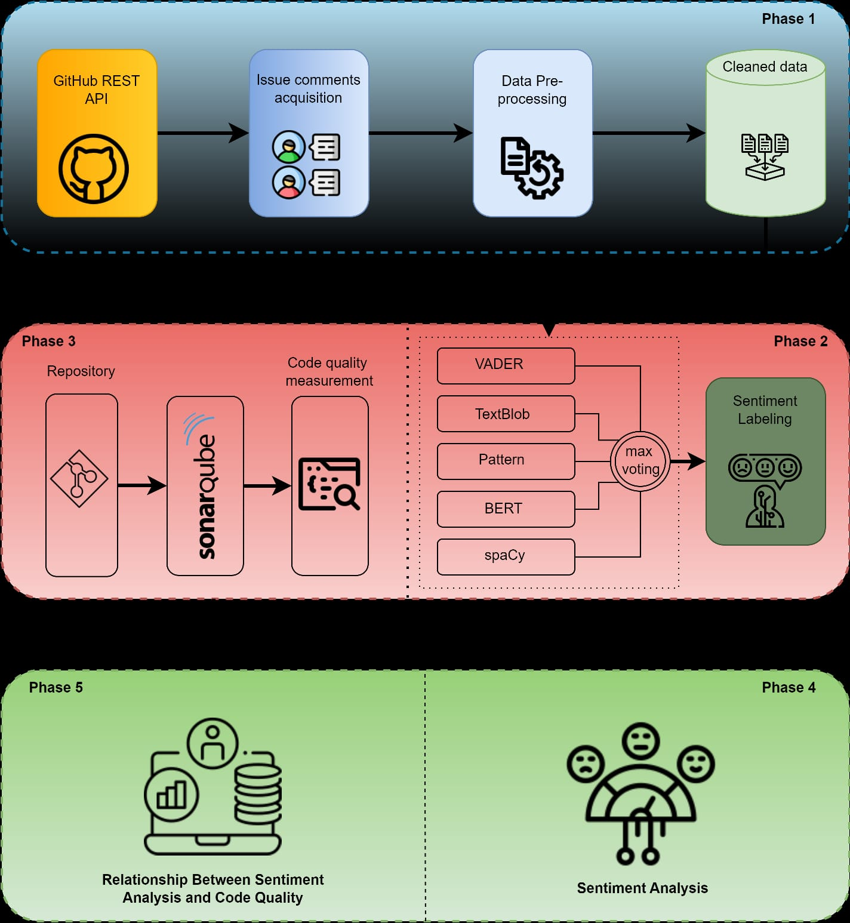

Key Visualization Techniques

Bar Charts: Useful for comparing the distribution of positive, negative, and neutral sentiments across categories, such as topics, demographics, or time periods.

Line Graphs: Track sentiment changes over time, revealing how emotions fluctuate in response to events or campaigns.

Pie Charts: Offer a snapshot of sentiment proportions, visually representing the share of each sentiment type within a dataset.

Heatmaps: Display sentiment intensity or frequency across variables (e.g., time, geography), helping to identify hotspots of emotional activity.

Word Clouds: Highlight the most frequent words associated with specific emotions or sentiment polarities, offering quick thematic insights.

Graph-Based Visualizations: Advanced systems use knowledge graphs to map relationships between sentiment, customer segments, and issues, enabling correlation analysis, pattern recognition, and anomaly detection.

Model Insights and Architecture

Traditional ML Approaches: Projects like SociOpinion use machine learning models (e.g., logistic regression) trained on TF-IDF features from pre-processed social media text to classify emotions as positive, negative, or neutral. Visualization of results is typically done with tools like Matplotlib to show sentiment distributions across categories.

AI and LLM-Driven Models: Modern sentiment analyzers leverage large language models (LLMs) for nuanced emotion detection, going beyond simple polarity to capture specific states like anger, frustration, or satisfaction. These models can be integrated with graph databases to create knowledge graphs, linking sentiment nodes to entities (customers, products, timestamps) for deeper analytics and visualization.

End-to-End Visualization Pipeline Example

Data Ingestion: Collect social conversation data from sources like Twitter, chat logs, or support tickets.

Pre-processing: Clean and transform text data, extract relevant features (e.g., using TF-IDF or embeddings).

Sentiment Classification: Use ML or LLM-based models to assign sentiment and emotion labels.

Graph Construction: Store sentiment data as nodes and link to relevant entities in a knowledge graph for advanced analytics.

Visualization: Generate interactive dashboards, sentiment timelines, heatmaps, and word clouds using tools like Tableau, Matplotlib, or Plotly to present findings to stakeholders.

Software and Tools

Dovetail: Provides a visual canvas that clusters insights by themes, tracks sentiment shifts, and enables collaborative analysis of emotional trends across multiple feedback sources.

Agent Helper Sentimental Analyzer: Integrates LLMs and knowledge graphs for real-time sentiment timelines, pattern recognition, and anomaly detection, with advanced visualization capabilities.

Python Libraries: Matplotlib, Seaborn, Plotly for custom visualizations; R’s ggplot2 for statistical graphics

10. Tools and Technologies Used

Tools and Technologies for Decoding Emotions through Sentiment Analysis of Social Conversations

A wide range of tools and technologies are used to decode emotions from social media and online conversations. These solutions leverage advances in natural language processing (NLP), machine learning, and artificial intelligence (AI) to interpret not just sentiment (positive, negative, neutral) but also nuanced emotions and intent behind text.
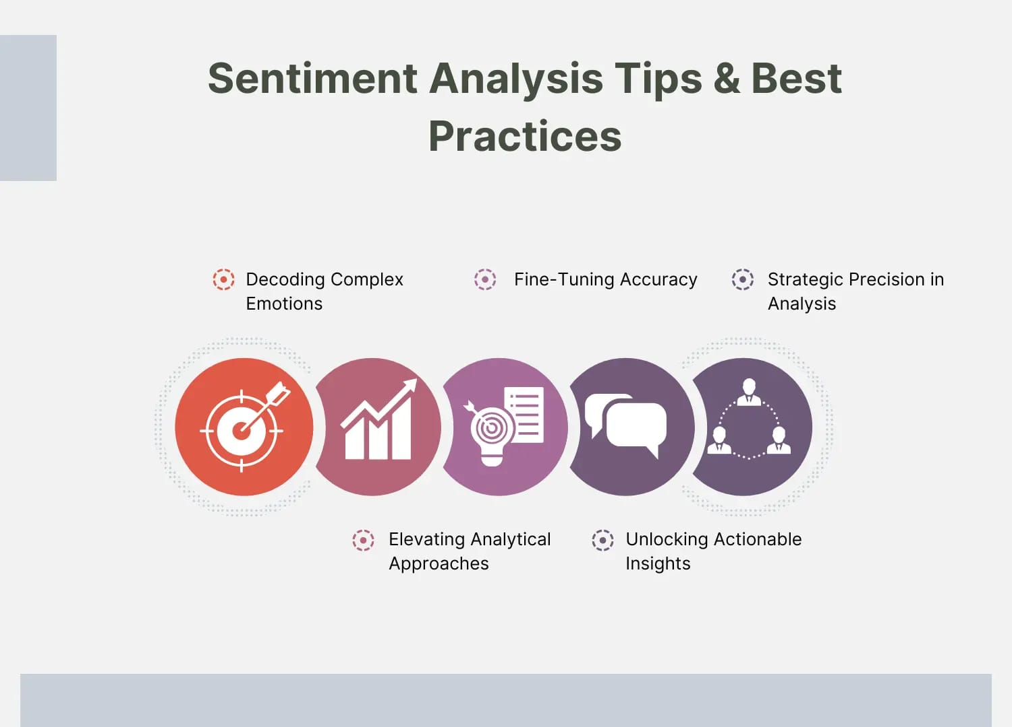

Key Technologies and Approaches

Natural Language Processing (NLP): NLP is foundational for sentiment and emotion detection. It enables machines to understand, interpret, and generate human language. Common tasks include tokenization, lemmatization, part-of-speech tagging, and named entity recognition.

Machine Learning Models: Algorithms such as logistic regression, support vector machines, and deep learning models are trained on labeled datasets to classify sentiment and emotions in text.

Large Language Models (LLMs): Modern tools increasingly use LLMs (e.g., ChatGPT) that can interpret context, sarcasm, and slang, leading to more accurate sentiment and emotion analysis.

Emotion Analysis: Beyond simple sentiment, advanced tools can recognize a spectrum of emotions (e.g., happiness, anger, surprise, disgust) using emotion lexicons or deep learning.

Popular Tools and Libraries

Tool/Library Key Features Best Use Cases

VADER Rule-based, handles emojis, slang, and acronyms; optimized for social media Social media posts, tweets

TextBlob Simple Python interface for NLP tasks, including sentiment analysis Beginners, prototyping

SentiStrength Provides nuanced sentiment scores for short texts Tweets, captions, short comments

Scikit-learn + NLTK Python libraries for custom ML/NLP pipelines (e.g., TF-IDF, logistic regression classifiers) Custom models, research

Sprout Social AI-powered, multi-platform, detects sentiment in complex sentences and emojis Brand monitoring, customer feedback

Qualtrics (Text iQ) Transformer-based, multilingual, topic-level sentiment scoring Enterprise feedback, surveys, CX

Zonka Feedback GenAI, NLP, contextual analysis, emotion/intent/urgency detection, workflow automation Customer experience, support triage

Dovetail AI sentiment tagging, thematic clustering, multi-source analysis Qualitative research, interviews

InMoment (Lexalytics) Multilingual, deep text analytics, emotion and intent detection Surveys, reviews, global feedback

Workflow and Techniques

Data Collection: APIs (e.g., Twitter API) and web scraping are used to gather public social media data.

Data Preprocessing :Cleaning text (removing URLs, special characters), tokenization, lemmatization, and conversion of emojis/slang to text.

Feature Extraction Techniques like TF-IDF convert text into numerical representations for machine learning models.

Sentiment & Emotion Analysis: Rule-based (e.g., VADER), machine learning, or deep learning models classify sentiment and detect emotions.

Some tools assign sentiment scores or identify multiple emotions within a single message.

Visualization & Reporting: Dashboards, visual summaries, and theme clustering help users interpret trends and insights.

Automation & Action: Advanced tools automate workflows based on detected sentiment or emotion (e.g., escalating negative feedback).

Team Members and Contributions
1. N.Lokeshwaran– Data Collection and Integration: Responsible for sourcing datasets, connecting APIs, and preparing the initial dataset for analysis.
2. M.Madhan kumar – Data Cleaning and EDA: Cleans and preprocesses data, performs exploratory analysis, and generates initial insights.
3.J.Jeeva – Feature Engineering and Modeling: Works on feature extraction and selection; develops and trains machine learning models.
4.R.Hariharan – Evaluation and Optimization: Tunes hyperparameters, validates models, and documents performance metrics.

